RESUME GUIDE
First (Preferred Name) Last

(770) 123-1234 email linkedin.com/in/YOURLINKEDINID

EDUCATION
Mercer University, Bachelor of Business Administration May 2021
Concentration in Marketing

Study Abroad Program, Madrid, Spain May-Aug 2020
- Completed Spanish immersion program with a focus on global business in formatting
- Developed operations systems recommendations designed to maximize gross product output under newly implemented sustainability regulations for XYZ Company as part

Society of Human Resource Management July 2018-May 2020
- Treasurer July 2019
- Vice President 2020

EXPERIENCE
CX Intern for Mercer Bear Corporation, Macon, GA September 2019 – May 2020
- Analyzed data to assist in team planning
- Allocated resources that would be available to marketing interns
- Managed website updates and upgrades under marketing team supervision
- Harnessed business acumen and understanding of total store process to make strategic decisions

Quality Assurance Analyst Intern for Marketing, Macon, GA May 2019 – September 2019
- Program Management and Customer Support
- Work within a team of 6 interns to continually, review, update. And upgrade website content based on student, staff, and departmental needs.

LEADERSHIP
- Captain of the men’s lacrosse team
- NCAA student-athlete leadership team for Mercer University

ACTIVITIES
- Volunteer, Women’s Crisis Help Line, Atlanta, GA June 2017 – Present
- Member, Women in Business Club, Mercer University September 2012 – June 2014

SKILLS

- Spanish – Intermediate Proficiency
- Excel Power User
- Advanced Google Analytics
- Google Ads
- Yellow Belt Lean Six Sigma

INTERESTS
Soccer | Outdoor Exploration | Minimalist Lifestyle | Travel
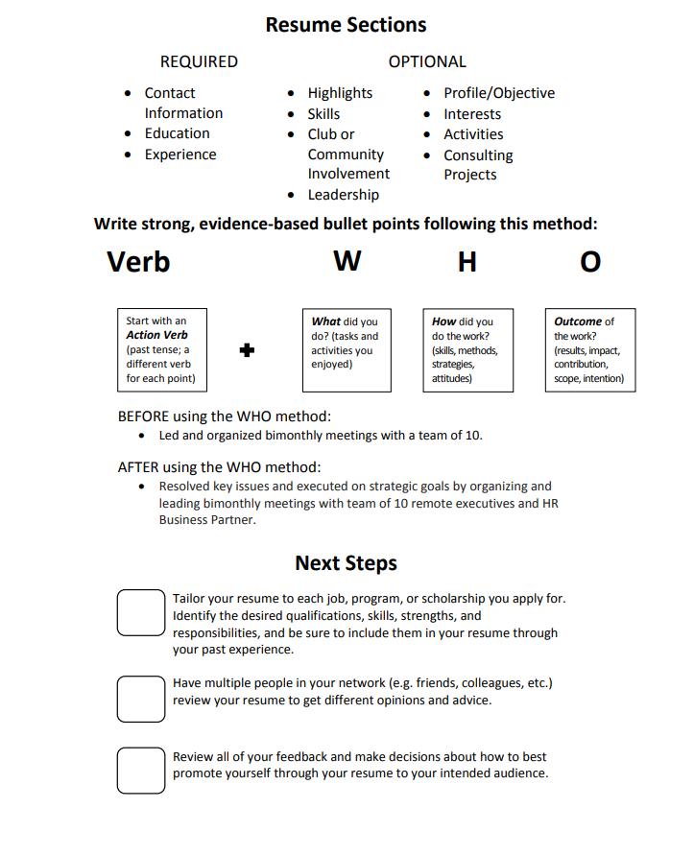
To Help Build Your Resume

